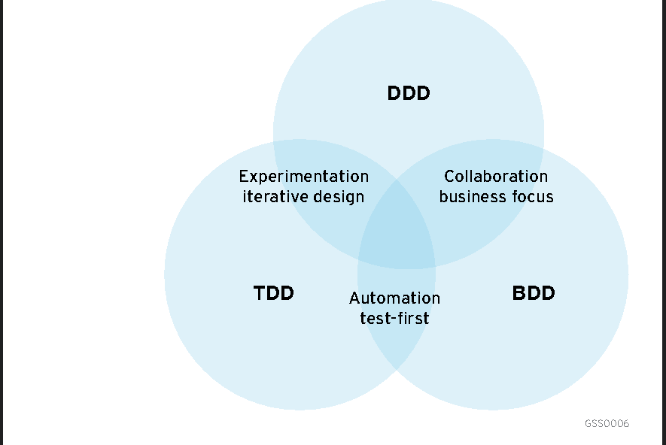**TDD, BDD and FDD Methodologies**

**Introduction**

* **Brief Overview**: Introduction to TDD, BDD, and FDD, and their importance in software development.

**2. Methodologies**

**Test-Driven Development (TDD)**

* **Approach**: Write tests before code.
* **Process**: Write a test -> Run the test -> Write code -> Run the test -> Refactor -> Repeat.
* **Visual**: Cycle diagram showing the TDD steps.

**Behaviour-Driven Development (BDD)**

* **Approach**: Write specifications based on behaviour.
* **Process**: Define behaviour in plain language -> Write tests based on behaviour -> Develop code -> Run tests -> Refactor -> Repeat.
* **Visual**: Flowchart showing steps from behaviour definition to testing and refactoring.

**Feature-Driven Development (FDD)**

* **Approach**: Develop by features.
* **Process**: Develop overall model -> Build feature list -> Plan by feature -> Design by feature -> Build by feature.
* **Visual**: Step-by-step diagram illustrating the FDD process.

**3. Benefits**

**TDD Benefits**

* **Bug Reduction**: Early detection and fixing.
* **Reliable Codebase**: Ensures code works as intended.
* **Facilitates Refactoring**: Encourages clean, maintainable code.
* **Visual**: Bug icon with a slash, shield with a checkmark, broom icon.

**BDD Benefits**

* **Improved Communication**: Clearer requirements through collaboration.
* **Better Alignment with Business Goals**: Focuses on user behavior.
* **Enhanced Test Coverage**: Comprehensive testing through behavior scenarios.
* **Visual**: Dialogue icon, target icon, checklist icon.

**FDD Benefits**

* **Scalable**: Works well for large projects.
* **Efficient Development**: Focuses on delivering features.
* **High Visibility**: Clear tracking of progress.
* **Visual**: Growth chart icon, feature flag icon, visibility icon.

**4. Suitability**

**TDD Suitability**

* **Best For**: Small to medium projects, code-centric development, projects requiring high reliability.
* **Visual**: Small to medium project icons, code symbol.

**BDD Suitability**

* **Best For**: Projects needing strong collaboration, complex requirements, customer-driven development.
* **Visual**: Team icon, complex flow diagram.

**FDD Suitability**

* **Best For**: Large projects, feature-centric development, projects needing clear progress tracking.
* **Visual**: Large project icon, roadmap symbol.